Add your logo here

We’re supporting
Carers Week

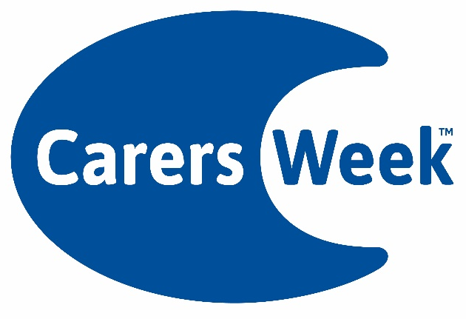
7th - 13thJune 2021

