Add your logo here

**I’m supporting**

**Carers Week**

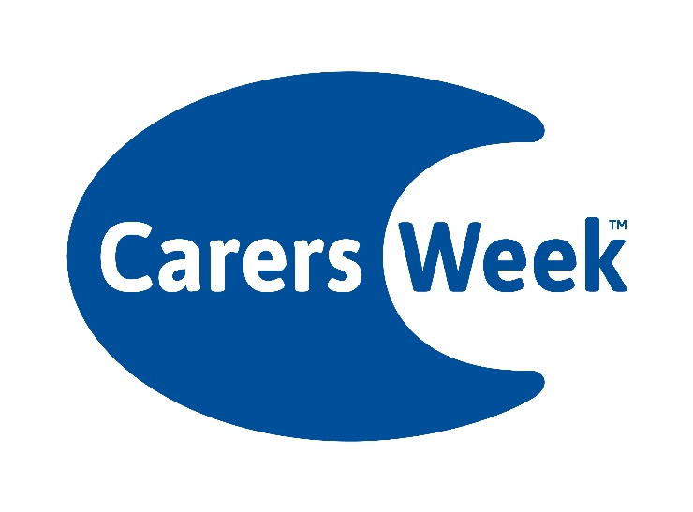

**7th - 13thJune 2021**