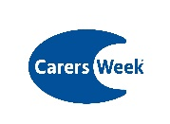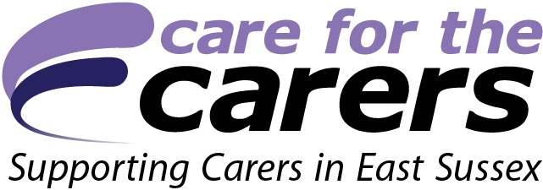

**Accessibility checklist – organising events for all**

People with access needs often face barriers when attending events that can make their participation very difficult or even impossible. They may experience difficulty hearing what is said, seeing small print, climbing steps to the venue, understanding signage or using a bathroom in the building. While you may not be able to achieve all of the points below, any considerations you make will be beneficial.

**PLANNING**

* Involve people with a disability in planning your event.
* Create a site map and signage for your event which highlights the location of accessible facilities and services to share with attendees.
* Ensure speakers and guests are also consulted about their access needs in advance.
* Ask attendees as part of the registration process if they require sign language translation/interpretation. Asking in advance gives you adequate time to book a local signer if required, as they can be high in demand in this area.
* If you have a hearing loop, check it is working correctly. If your venue doesn’t have a hearing loop then consider providing one to assist people with a hearing impairment..
* Ensure that staff are aware of procedures to address how people with disabilities will be assisted in the event of an emergency.
* Conduct staff and volunteer basic awareness training to ensure event representatives know how to interact with people with disability.

**MARKETING YOUR EVENT**

* Highlight upfront the accessible aspects of your event, so that people can gauge the level of difficulty of participating in an event (parking, toilets, ramps, interpreting…) or what they might need to request provision for.
* Consider the language you use in your event communication – is it inclusive?
* If you have a booking system, provide options for booking on the phone, online, in person and by post, to ensure as many people as possible are able to book in the most simple way for them.
* Provide contact details for the event organisers so people can pose questions about accessibility.
* Where possible provide promotional and event materials in plain language and accessible formats (eg large print, audio and digital alternatives).
* Avoid embedded text in images online – screenreaders can’t access information contained in images, so ensure alt text and/or an alternative is provided.

**EVENT VENUE**

* Provide accessible parking if possible, or highlight the closest accessible bays nearby.
* Outline public transport options for accessing your event – think about drop-off area close to the entrance?
* Are steps, ramps, spaces for wheelchairs and seating areas provided?
* Consider varied seating options for different impairments – do seats have back and arm rests?
* Consider if PowerPoint slides or videos are accessible to as many as possible – provide captions and audio descriptions if applicable.
* Consider if lighting adjustments need to be made to enable clear line of sight to doors/amenities.
* Are extra chairs required for any carers also attending?
* Do you have accessible toilets?
* Does the venue accept assistance dogs?
* Are refreshments easily accessible? Ensure space and signage is clear.

**Many thanks to Disability Inclusion CIC based in East Sussex for its guidance workshop on creating accessible events, March 2018, which helped inform this document.**

[www.disabilityinclusion.co.uk](http://www.disabilityinclusion.co.uk/)